Setup an active directory group for VMG

Step1: Select the domain controller (e.g. vmg.com) as shown below, right click and select New -> Group option from menu.
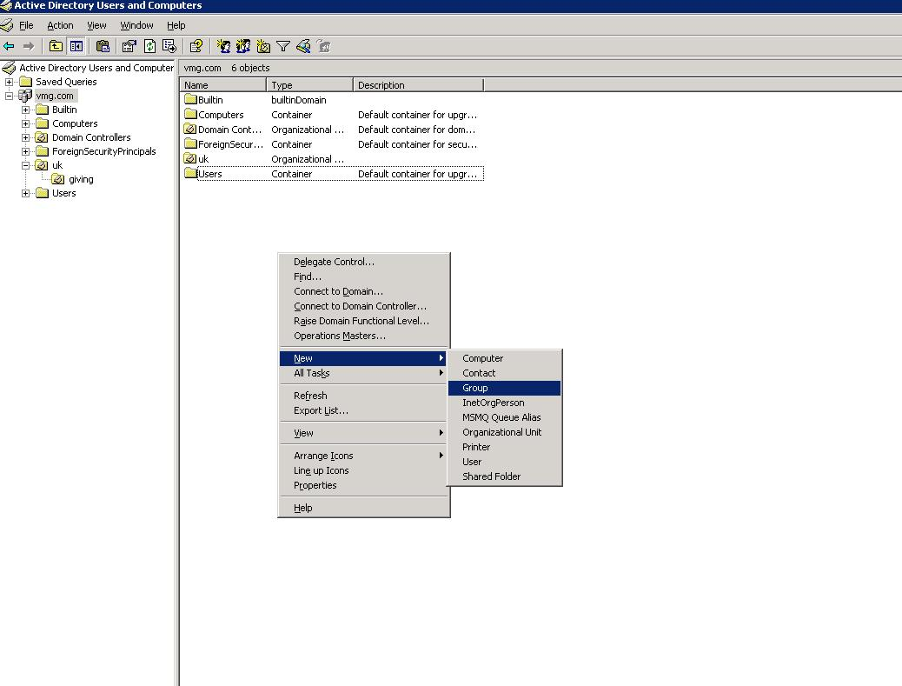

Step2- Enter Group Name, select Group scope and type as shown below. 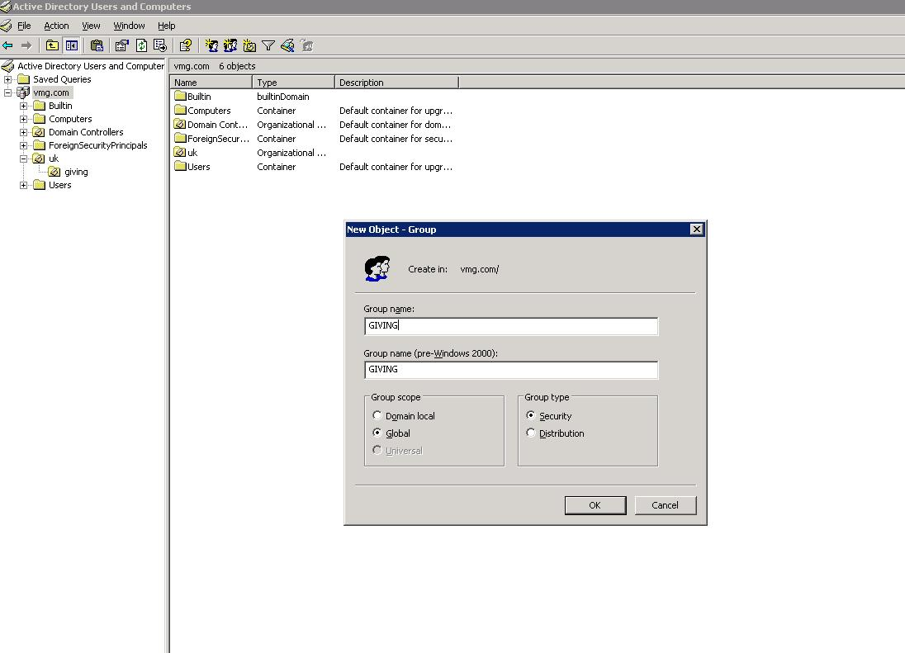

*** Please note that Group scope has been selected to Global, you can change it to go with your domain policy.

Step3: Click Ok to finish.
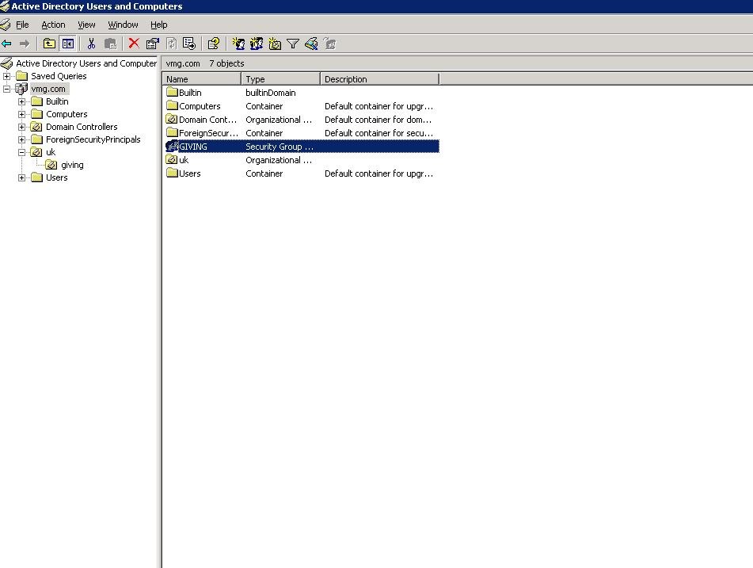

Setup an active directory user for VMG

Step1: Select Organisational Unit (OU) VMG users will be part of. In the below example it is “uk -> giving”

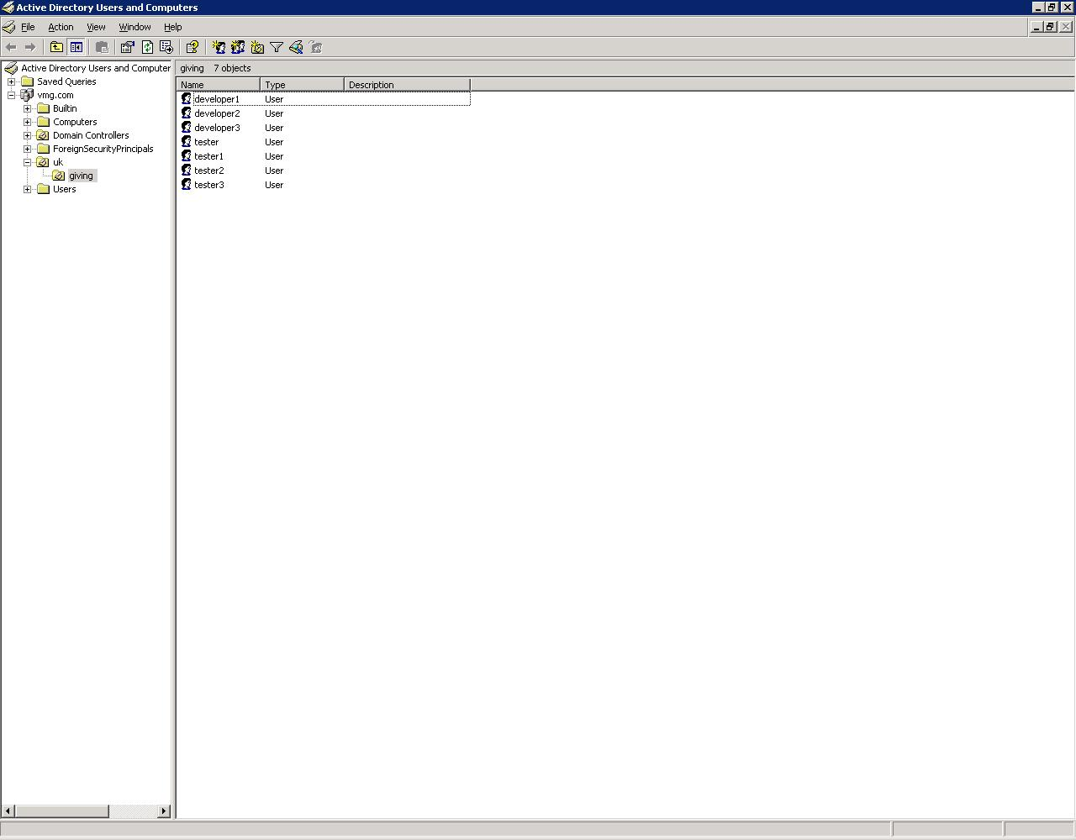

Step2: Right click and select New -> User menu option as shown below
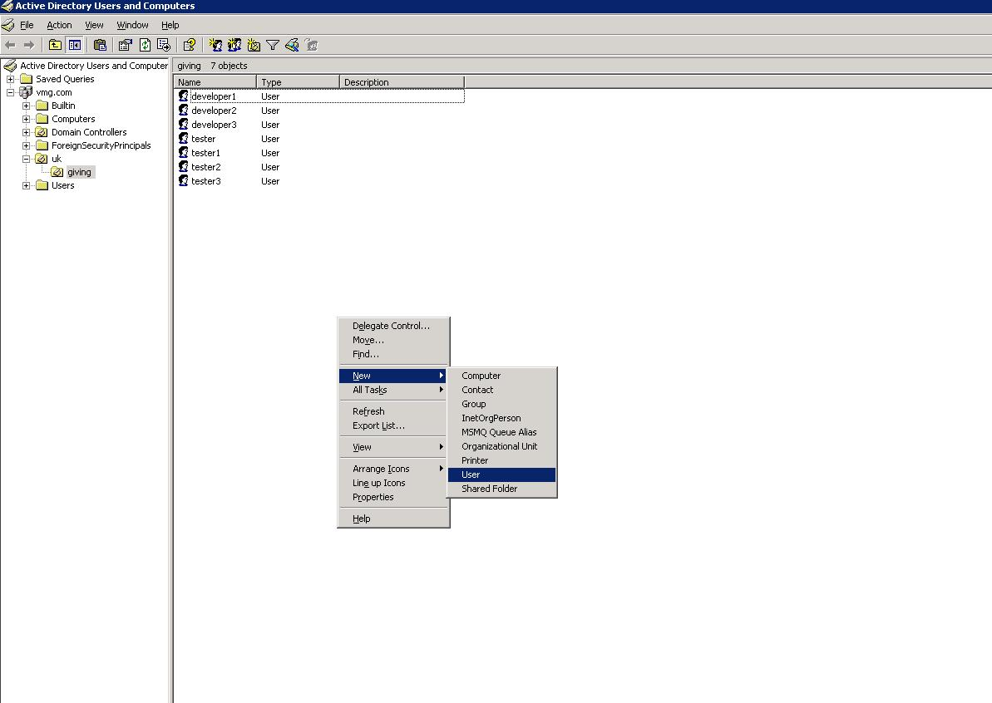

Step3: Enter details as shown below and click Next
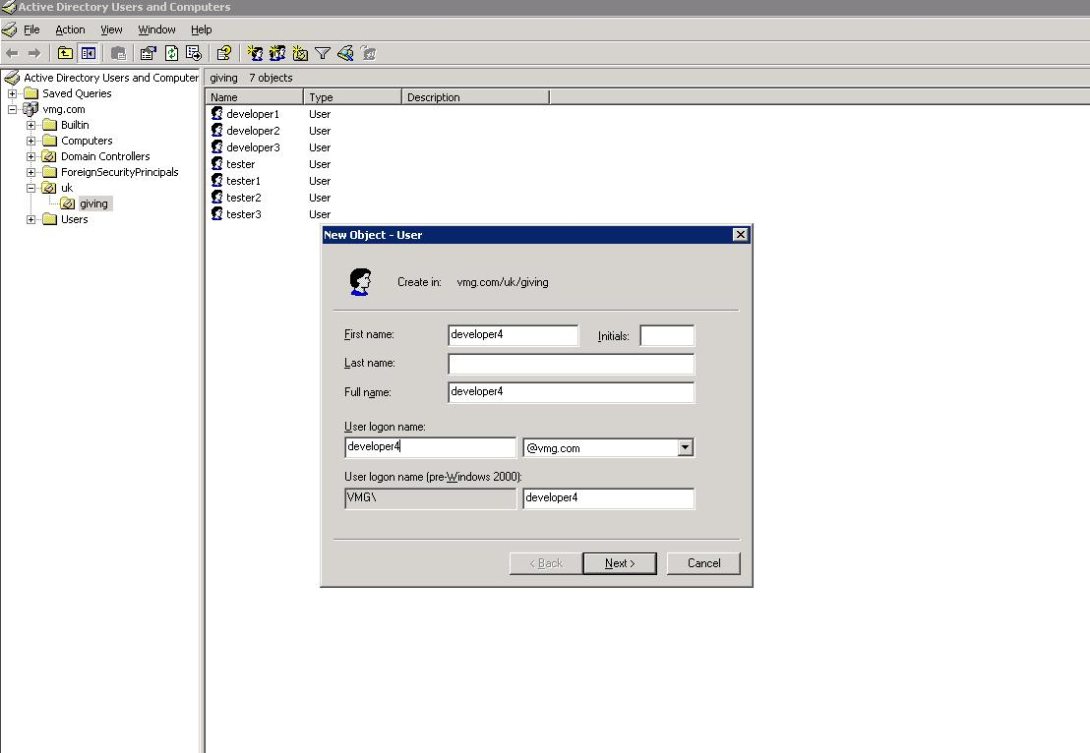

Step4: Enter details as shown below and click Next
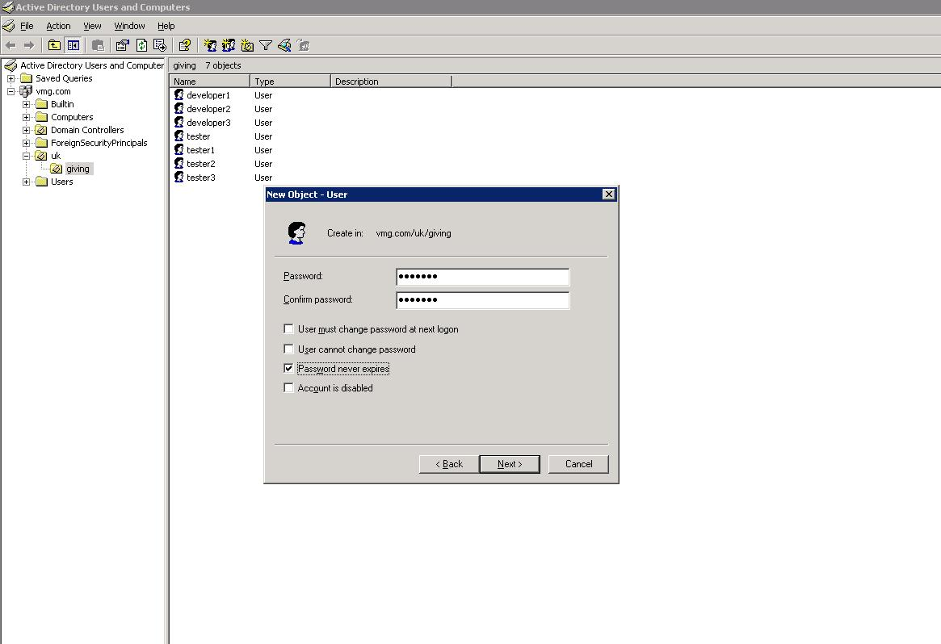

Step5: Click Finish
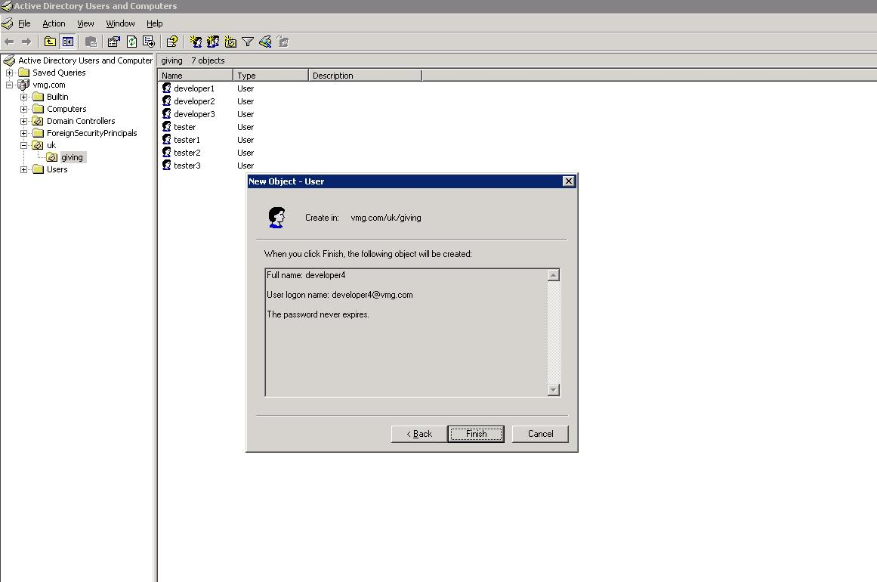

Setup an active directory user – group association for VMG users.

Step1: Select the domain controller root and right click on the group created earlier (in this example GIVING), select Properties menu option.
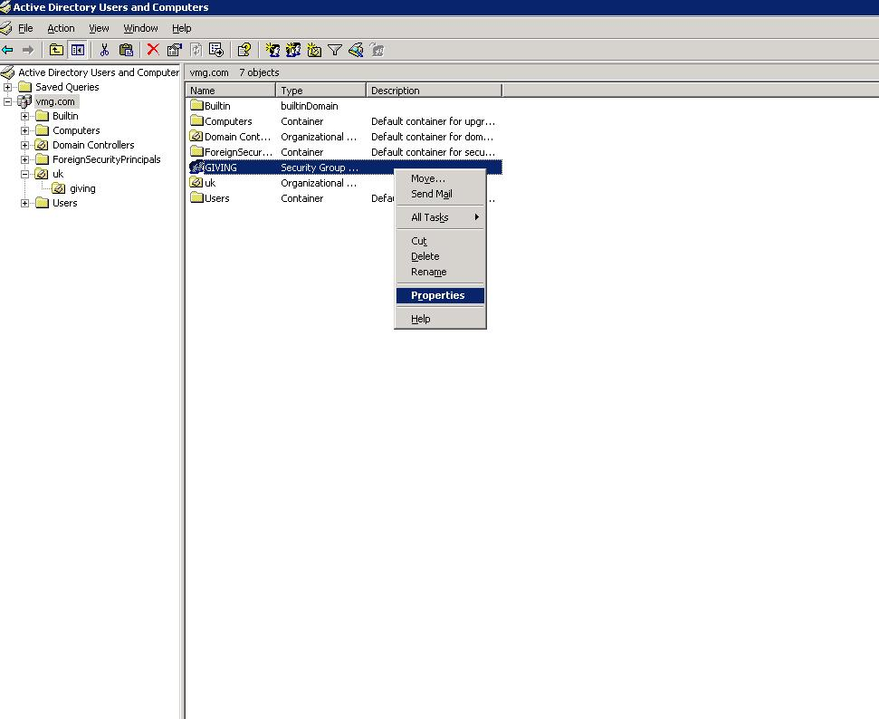

Step2: Select Members tab as shown below.
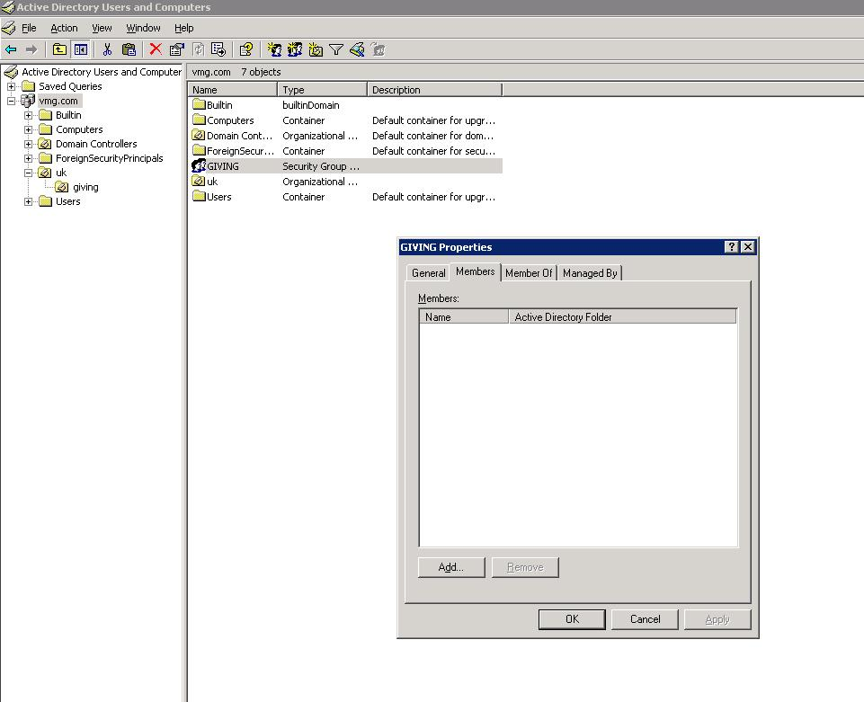

Step3: Click on Add, enter name of the VMG user to be associated with this group.
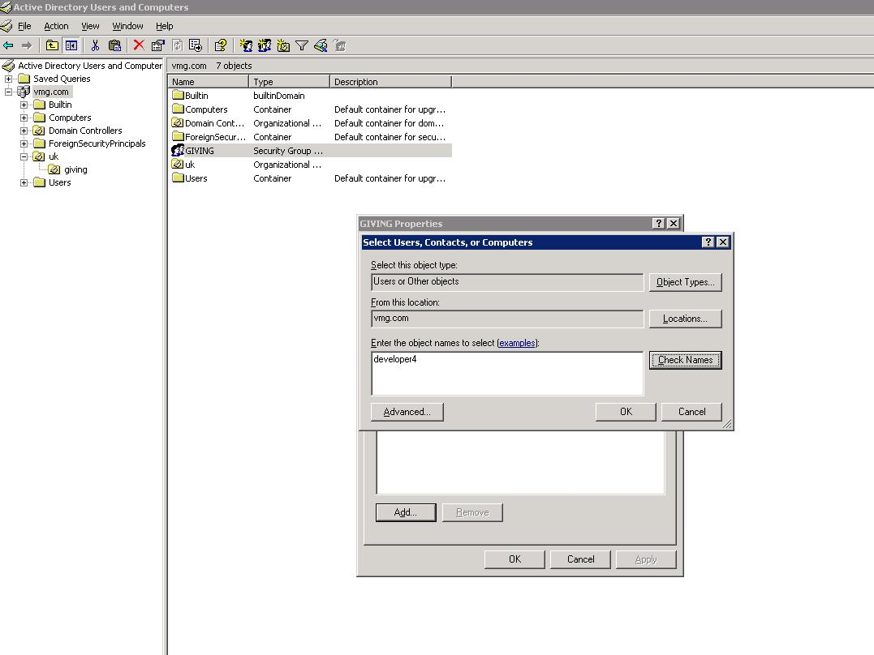

Step4: Click on Check Names
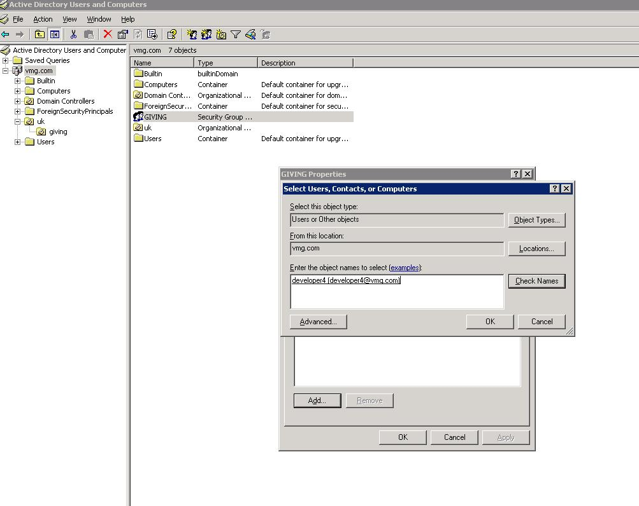

Step5: Click Ok to finish.
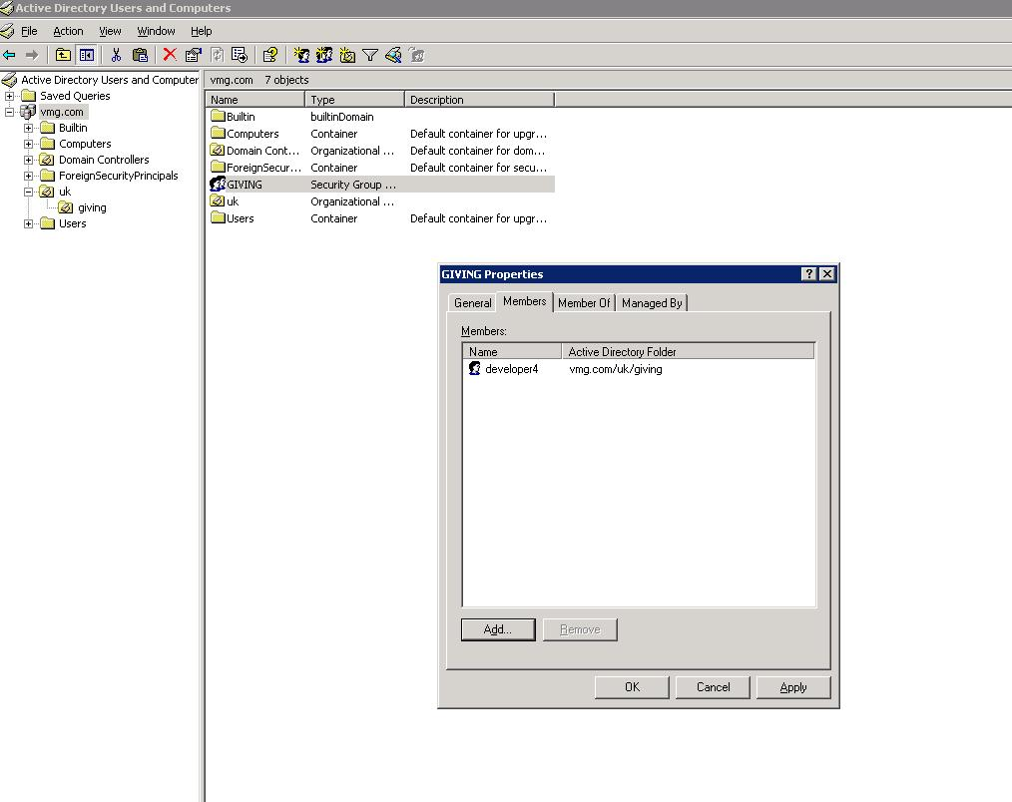

Application level settings

Modify external-configuration -> vmg-ldap.properties in the external configuration folder as shown below

ldap.url=ldap://{directory server location}:{directory server port}

Replace placeholders to point to correct location
Example:
ldap.url=ldap://10.0.5.100:389

ldap.base={Base domain controller pattern
Replace placeholders to point to correct domain controller structure of the active directory server.
Example
ldap.base=dc=vmg,dc=com

ldap.adminName={Admin userDn}
Replace placeholders to point to correct a userDn on the active directory server. This user account will be used to establish connection with active directory server and perform subsequent operations.
Example :
ldap.adminName=CN=Administrator,CN=Users,DC=vmg,DC=com

ldap.adminPassword={Admin user password}
Replace placeholders to point to correct value.

ldap.userbasedn={User base DN on the active directory server}
Replace placeholders to point to correct userbase dn on the active directory server. This property will define the scope of user search on the active directory server tree. Example
ldap.userbasedn=cn={0},ou=giving,ou=uk

giving.default.group={DEFAULT USER GROUP}
Replace placeholders to point to correct group on the active directory server.
This property will be used to perform user group verification on the AD server.
Example:
giving.default.group=GIVING

Active directory tree structure used in the example is setup as below

com (defined as domain controller (dc))
-|
vmg (defined as domain controller (dc))
-|
uk (defined as Organisational Unit (ou))
-|
giving (defined as Organisational Unit(ou))

** All user accounts are created under 'giving' organisational unit.
** An active directory group GIVING has been created.
** Users are added to GIVING group.

